Motional AD LLC.

Component Common Requirement Document

ENG-REQ-EMC-1.3

**Electromagnetic compatibility Requirements for Components**

**Revision Record**

|  |  |  |  |
| --- | --- | --- | --- |
| Revision Level | Revision Date | Author | Change Description and Section(s) Affected by The Change |
| 1.0 | Nov 11, 2020 | Wun Leng, Lee | Initial draft |
| 1.1 | Dec 19, 2020 | Wun Leng, Lee | Draft for review |
| 1.2 |  |  | Draft for review |
|  |  |  |  |
|  |  |  |  |
|  |  |  |  |
|  |  |  |  |
|  |  |  |  |
|  |  |  |  |

**Table of Contents**

1. Scope of the Document 5

1.1 Scope of Document 5

1.2 Word Format and Conventions 5

2. Overview 6

2.1 Purpose 6

2.2 Communications 6

3. EMC Requirements 6

4. Use Cases and Component Types 7

5. Standardization and Its Limitations 7

6. Reference Documents 8

7. Abbreviations 8

8. Operating modes based 9

8.1 Operating mode 1 9

8.2 Operating mode 2 9

8.3 Operating mode 3 9

9. Functional Performance Status Classification (FPSC) 9

9.1 Functional Performance Status 9

9.1.1 Status I 9

9.1.2 Status II 9

9.1.3 Status III 10

9.1.4 Status IV 10

9.2 Test Severity Level 10

9.3 FPSC approach 10

10. List of components considered 11

11. Component Category Classification table 11

12. Test and Standard Selection Matrix 11

13. General Lab Test Requirements, If not provided 13

14. Requirements 13

14.1 Radiated Emission in ALSE 13

14.2 Conducted Emissions - Voltage on Power leads 13

14.3 Conducted Emissions - Current probe on cable harness 13

14.4 Interference immunity - BCI on cables 14

14.5 Interference Immunity - ALSE (Antenna) 14

14.6 Interference Immunity – Magnetic Fields 14

14.7 Conducted Transient on power lines 14

14.8 Conducted Immunity to Transient on power lines 14

14.9 Coupled Transient Interference on cable harness 14

14.10 Powered Electrostatic Discharge (ESD) 14

14.11 Handling Electrostatic Discharge (ESD) 15

15. References 16

15.1 Industry Standards 16

15.2 Motional Requirements 16

15.3 Acronyms and Terms 17

# Scope of the Document

## Scope of Document

This document is a Process and Methodology for Electromagnetic compatibility.

## Word Format and Conventions

The word SHALL denotes a mandatory design requirement. The word SHOULD denotes a desired, but not mandatory design requirement. The word WILL denotes a statement of fact.

# Overview

Motional is preparing to launch its first Automated Mobility on Demand (AMoD) product at scale for use in ride-hailing networks in the United States, the European Union, Singapore, China, and Japan. That product launch includes four key elements to the product:

1. automated driving tech (components, computers, software),
2. vehicle platform,
3. mobility services cloud, and
4. reference infrastructure solution.

Motional’s product sale encompasses all four of these elements in a turnkey sale directly to ride-hailers.

## Purpose

As part of the requirements stipulated for each component within the architecture for the product, common requirements have been identified for Electromagnetic compatibility and hereby documented with the intent that ALL component suppliers to the vehicle architecture demonstrate compliance.

## Communications

Please confirm receipt of this document to [wun.leng.lee@motional.com](mailto:wun.leng.lee@motional.com) Additionally, if further clarification or questions arise, please direct your questions to her.

## EMC Requirements

- In vehicles, electrical/electronic components and subsystems used by Motional Company should clear an EMC evaluation.

- In terms of DUT and vehicle EMC standards, tests can be conducted under special circumstances, and required performance can be adjusted prior to revision of the standard to reflect market trends such as the application of new technologies, field claims, and so on. The DUT supplier is responsible for inspecting the improvement, submitting reviews on additional part tests, and conducting enhanced and additional tests.

## Use Cases and Component Types

The following type of [Component] are considered:

1. A component or module that contains active electronic devices. (EC)
2. An electronic component or module that contains magnetically sensitive elements. (EM)
3. An electronic component or module operated from a regulated power source in another module. This is usually a sensor providing input to a controller. (ES)

## Standardization and Its Limitations

- The standard's test methods and technical specification were based on an international standard for EMC testing of components and vehicles that was distributed or under review for revision, and a part of the experience gained was reflected to ensure EMC performance in actual vehicles.

- The test methods and performance criteria are protected depending on the Motional components and specifications, and the restrictions are mostly focused on Europe and the United States based on Motional requirements. Aside from US and European assessments, normal limits will be considered during tests depending on the country's requirements.

- Product suppliers and Motional Company's responsible engineering-design/distribution departments should decide the following products.

* Data for determining the DUT's feature classification (CLASS 1/2/3/4)
* Choosing EMC test products that apply to the DUT
* Determination of DUT test mode and definition (tolerance) of DUT regular activity status.
* Norm Of ENGINEERING
* Writing an EMC Research Plan
* Deciding on a facility for DUT testing
* Submitting a test report to Motional Company's EMC Test Department

- If the contents of a different component standard conflict with the standard, the standard prevails.

- All electrical/electronic components and sub-systems should comply with the standard requirement.

- The engineering-design/distribution divisions of the Motional company, as well as product suppliers, are in charge of identifying the service output status and deciding the test mode of the DUT.

- Motional engineering-design/distribution divisions are in charge of determining if the standard's specifications are relevant.

- It is the responsibility of component manufacturers to perform tests in accordance with the specifications of the specification.

- The final degree of satisfaction with the DUT's EMC test result should be decided by Motional Company's EMC test department.

- The specification was written to anticipate problems, such as consumer satisfaction with performance/quality, and it will be updated to meet the vehicle's target level.

- There may be a discrepancy in test results due to the lack of an appropriate correlation coefficient for the correlation between part and in-vehicle tests, as well as measurement uncertainty.

As a result, EMC tests must be carried out in real vehicles that are fitted with the entire system..

- The typical vehicle test result must not be used as a substitute for the DUT test result.

- If the standard needs to be changed, a request should be made to Motional Company's EMC test department, and the requested item will be checked and either reflected in the next revision or immediately updated, depending on its value.

- Any DUT tested according to the standard must follow the standard when randomly extracting approved components from the proto and pilot production process (including the pilot production preparation phase). The related component manufacturers must be pre-qualified with appropriate samples for this purpose by developing their own reliable verification system.

# Reference Documents

|  |  |
| --- | --- |
| **Standard** | **Description** |
| CISPR 25:2016 | Vehicles, boats and internal combustion engines - Radio disturbance characteristics - Limits and methods of measurement for the protection of on-board receivers |
| ISO 11452-4: 2020 | Road vehicles — Component test methods for electrical disturbances from narrowband radiated electromagnetic energy — Part 4: Harness excitation methods |
| ISO 11452 - 2:2019 | Road vehicles — Component test methods for electrical disturbances from narrowband radiated electromagnetic energy — Part 2: Absorber-lined shielded enclosure |
| ISO 11452 - 8:2015 | Road vehicles — Component test methods for electrical disturbances from narrowband radiated electromagnetic energy — Part 8: Immunity to magnetic fields |
| ISO 11452-9:2012 | Road vehicles — Component test methods for electrical disturbances from narrowband radiated electromagnetic energy — Part 9: Portable transmitters |
| ISO 7637-2:2011 | Road vehicles — Electrical disturbances from conduction and coupling — Part 2: Electrical transient conduction along supply lines only |
| ISO 7637-3:2016 | Road vehicles — Electrical disturbances from conduction and coupling — Part 3: Electrical transient transmission by capacitive and inductive coupling via lines other than supply lines |
| EN 61000-4-2:2008, ISO 10605:2008 | Electromagnetic compatibility (EMC) - Part 4-2: Testing and measurement techniques - Electrostatic discharge immunity test,Road vehicles — Test methods for electrical disturbances from electrostatic discharge |
| ISO 7637-1: 2015 | Road vehicles — Electrical disturbances from conduction and coupling — Part 1: Definitions and general considerations |
| ISO 11452-1: 2015 | Road vehicles — Component test methods for electrical disturbances from narrowband radiated electromagnetic energy — Part 1: General principles and terminology |
| IEC 61000-3-2:2018 | Electromagnetic compatibility (EMC) – Part 3-2: Limits – Limits for harmonic current emissions (equipment input current ≤ 16 A per phase) |
| IEC 61000-3-3:2013/AMD2:2021 | Electromagnetic compatibility (EMC) – Part 3-3: Limits – Limitation of voltage changes, voltage fluctuations and flicker in public low-voltage supply systems, for equipment with rated current ≤ 16 A per phase and not subject to conditional connection |
| IEC 61000-3-4:1998 | Electromagnetic compatibility (EMC) - Part 3-4: Limits - Limitation of emission of harmonic currents in low-voltage power supply systems for equipment with rated current greater than 16 A |
| IEC 61000-3-5:2009 | Electromagnetic compatibility (EMC) – Part 3-5: Limits – Limitation of voltage fluctuations and flicker in low-voltage power supply systems for equipment with rated current greater than 75 A |
| IEC 61000-3-11:2017 | Electromagnetic compatibility (EMC) - Part 3-11: Limits - Limitation of voltage changes, voltage fluctuations and flicker in public low-voltage supply systems - Equipment with rated current ≤ 75 A and subject to conditional connection |
| IEC 61000-3-12:2011 | Electromagnetic compatibility (EMC) - Part 3-12: Limits - Limits for harmonic currents produced by equipment connected to public low-voltage systems with input current >16 A and ≤ 75 A per phase |

# Abbreviations

* Absorber-Lined Shielded Enclosure: ALSE
* Bulk Current Injection: BCI
* Current Injection Probe: CIP
* Current Measuring(Monitoring) Probe: CMP
* Device Under Test: DUT
* Electromagnetic Compatibility: EMC
* **Electrostatic Discharge:** ESD

# Operating modes based

Need to be defined on component level for emc requirements

# Functional Performance Status Classification (FPSC)

Need to be defined on component level for emc requirements

# List of components considered

LR-LIDAR, SR-LIDAR, RADAR, CAMERAS (1003-Narrow, 1004-Moderate, 1005-Wide), GNSS (IMU / GPS / V2X), External Microphone, Services/Teleops (RVA), Drive By Wire Controller, Mission Services Platform, AV Compute, Cabin Monitoring System, AEB Hardware Solution (Radar, Camera),R&D Logging, R&D Compute, Exterior Audio (Speaker), Passenger Displays (AVN), External Display(FRT), Authentication Pad, Passenger Displays (RSE), Side LED strips

# Component Category Classification table

|  |  |
| --- | --- |
| **Component Category Classification Table** | |
| **Category** | **Component Category Description** |
| **L1** | Any electronic unit or part which does not consist electronic components |
| **L2** | Electronic parts or units with no control mechanism and passive components; such as inductor, capacitor, filter and LED's |
| **L3** | Electronic parts or units with control and monitoring feature; such as units consisting of active senor, display system, microcontrollers and integrated circuits |
| **SUB Category for additional tests** | |
| **SC1** | Electronic parts like keyfob and tyre pressure monitor, which does not need a vehicle connection to function. |
| **SC2** | For any electric vehicle power system, an electronic component that operates at more than 60V. |
| **SC3** | Electronic component that gets its power from another component's controlled power supply. Typically, this is a sensor that provides information to a controller. |
| **SC4** | Motors and electronically controlled motors are examples of electronic components that include an electronically controlled motor or a magnetically driven component within their package or drive an external inductive system. |
| **SC5** | Magnetically sensitive elements which are located in an electronic unit. |
| **SC6** | A brush commutated DC electric motor with a long operating time or an auto cycle brush commutated DC electric motor, say > 5 seconds |
| **SC7** | Switching components such as solenoid and relays pulsed at a rate < 100Hz. |
| **SC8** | Electronic component connected to AC mains |
| **SC9** | Pulse rates of 100Hz or higher which are used in inductive units. |

# Test and Standard Selection Matrix

|  |  |  |  |  |  |  |  |  |  |  |  |  |  |  |  |  |  |  |  |  |  |  |  |  |  |  |  |  |  |  |  |
| --- | --- | --- | --- | --- | --- | --- | --- | --- | --- | --- | --- | --- | --- | --- | --- | --- | --- | --- | --- | --- | --- | --- | --- | --- | --- | --- | --- | --- | --- | --- | --- |
| **Test and Standard standard Matrix** | | | | | | | | | | | | | | | | | | | | | | | | | | | | | | | |
| **Tests** | **Category** | | | **SUB Category for additional tests** | | | | | | | | | **Reference Standard** | | | | | | | | | | | | | | | | | | |
| **Generic EMC Test** | **L1** | **L2** | **L3** | **SC1** | **SC2** | **SC3** | **SC4** | **SC5** | **SC6** | **SC7** | **SC8** | **SC9** | **CISPR 25:2016** | **ISO 11452-1: 2015** | **ISO 11452-4: 2020** | **ISO 11452 -2:  2019** | **ISO 11452 - 8: 2015** | **ISO 11452-9: 2012** | **ISO 7637-1: 2015** | **ISO 7637-2: 2011** | **ISO 7637-3: 2016** | **EN 61000-4-2: 2008** | **ISO 10605:2008** | **IEC 61000-3-2:2018** | **IEC 61000-3-3:2013/AMD2:2021** | **IEC 61000-3-4:1998** | **IEC 61000-3-5:2009** | **IEC 61000-3-11:2021** | **IEC 61000-3-12:2011** | **MIL-STD-461F** |
| **Conducted Emissions - Voltage on Power leads** |  |  | **x** |  | **x** | **x** | **x** | **x** | **x** |  | **x** | **x** | **x** |  |  |  |  |  |  |  |  |  |  |  |  |  |  |  |  |  |
| **Conducted Emissions- Current probe on cable harness** |  |  | **x** |  |  | **x** | **x** |  | **x** |  | **x** |  | **x** |  |  |  |  |  |  |  |  |  |  |  |  |  |  |  |  |  |
| **Radiated Emission in ALSE** |  |  | **x** | **x** | **x** | **x** | **x** | **x** | **x** |  | **x** |  | **x** |  |  |  |  |  |  |  |  |  |  |  |  |  |  |  |  |  |
| **Conducted Transient Emissions** | **x** | **x** | **x** |  |  |  |  | **x** | **x** | **x** | **x** | **x** |  |  |  |  |  |  |  | **x** |  |  |  |  |  |  |  |  |  |  |
| **Interference immunity - BCI on cables (RI)** |  |  | **x** |  | **x** | **x** | **x** |  |  |  | **x** |  |  | **x** | **x** |  |  |  |  |  |  |  |  |  |  |  |  |  |  |  |
| **Interference Immunity - ALSE (Antenna)(RI)** |  | **x** | **x** |  | **x** | **x** | **x** |  |  |  | **x** |  |  |  |  | **x** |  |  |  |  |  |  |  |  |  |  |  |  |  |  |
| **Interference Immunity – Magnetic Fields** |  | **x** | **x** |  | **x** | **x** | **x** | **x** |  |  | **x** |  |  |  |  |  | **x** |  |  |  |  |  |  |  |  |  |  |  |  |  |
| **Conducted Transient Immunity on power lines** |  | **x** | **x** | **x** |  |  |  |  |  |  | **x** |  |  |  |  |  |  |  |  | **x** |  |  |  |  |  |  |  |  |  |  |
| **Transient immunity on signal line** |  | **x** | **x** | **x** |  |  |  |  |  |  | **x** |  |  |  |  |  |  |  |  |  | **x** |  |  |  |  |  |  |  |  |  |
| **Transient Immunity of supply lines or Sensor Lines – Coupling Clamp (CCC)** |  | **x** | **x** |  | **x** | **x** | **x** |  | **x** |  | **x** |  |  |  |  |  |  |  |  |  | **x** |  |  |  |  |  |  |  |  |  |
| **Transient Immunity of supply lines or Sensor Lines - Direct Capacitive Coupling (DCC)** |  | **x** | **x** |  | **x** |  |  |  |  |  | **x** |  |  |  |  |  |  |  | **x** |  | **x** |  |  |  |  |  |  |  |  |  |
| **Handling Electrostatic Discharge (ESD)** |  | **x** | **x** | **x** | **x** | **x** | **x** |  |  |  | **x** |  |  |  |  |  |  |  |  |  |  |  | **x** |  |  |  |  |  |  |  |
| **Powered Electrostatic Discharge (ESD)** |  | **x** | **x** | **x** | **x** | **x** | **x** |  |  |  | **x** |  |  |  |  |  |  |  |  |  |  | **x** |  |  |  |  |  |  |  |  |
| **Harmonic current transient** |  | **x** | **x** |  |  | **x** |  |  |  |  | **x** |  |  |  |  |  |  |  |  |  |  |  |  | **x** |  |  |  |  | **x** |  |
| **Voltage fluctuation and flicker** |  | **x** | **x** |  | **x** | **x** | **x** |  |  | **x** | **x** |  |  |  |  |  |  |  |  |  |  |  |  |  | **x** |  |  | **x** |  |  |
| **Electrical fast transient/burst immunity test** |  | **x** | **x** |  |  | **x** |  |  |  |  | **x** |  |  |  |  |  |  |  |  |  |  |  |  |  |  | **x** |  |  |  |  |
| **Surge transient** |  | **x** | **x** |  |  | **x** |  |  |  |  | **x** |  |  |  |  |  |  |  |  |  |  |  |  |  |  |  | **x** |  |  |  |
| **Conducted Transient Immunity, Jumpstart & Reverse Polarity** | **x** | **x** | **x** |  |  | **x** |  |  |  | **x** | **x** |  |  |  |  |  |  |  |  |  |  |  |  |  | **x** |  |  |  |  |  |
| **Portable Transmitter** |  | **x** | **x** |  | **x** | **x** | **x** | **x** |  |  | **x** |  |  |  |  |  |  | **x** |  |  |  |  |  |  |  |  |  |  |  |  |
| **Magnetic field Emission** |  |  |  |  | **x** |  | **x** | **x** |  |  | **x** |  |  |  |  |  |  |  |  |  |  |  |  |  |  |  |  |  |  | **x** |

# General Lab Test Requirements, If not provided

|  |  |
| --- | --- |
| Temperature | (23.0 ± 5.0) ℃. |
| Humidity | 20 to 80 % |
| Unit of Length | mm |
| Tolerances for capacitor, Inductor, Impedance | ± 10 % |
| Tolerances for Power, Energy, Transient voltage amplitude | (+ 10, - 0) % |

# Requirements

## Radiated Emission in ALSE

Test Specification reference: CISPR-25 Section 6.5

Additional coverage:

* + - * Coverage up to 6GHz for DSRC operating range.
      * Include coverage for GNSS Band for GPS L1 & L2, GLONASS G1 & G2, Galileo E1 & E6

Acceptance Criteria: DUT shall meet CISPR 25 Section 6.5 table 7 Class 4 as a minimum.

**Purpose:**

Purpose of this test to know the effect of electromagnetic radiation that is generated from various ECUs and other subsystem of the vehicle, which can interfere with the external radio signal, broadband signals, and other GPS signal from satellite also it can interfere with receiving signals in the vehicle.

Measurements of radiated field strength shall be made in an ALSE, this test will measure the radiation from the wire harness of the DUT.

**References Documents:**

CISPR25

**Test subject:**

**Test Frequency:**

Test frequency range from 0.15MHz to 2500MHz.

**Test Facility stet up:**

**Antenna systems:** Measurements shall be made using linearly polarized electric field antennas that have a nominal 50 Ω output impedance.

**Location of the EUT:** The EUT shall be placed on a non-conductive, low relative permittivity material (εr ≤ 1,4), at (50 ± 5) mm above the ground plane.

**Test harness and location:** The total length of the test harness between the EUT and the load simulator shall not exceed 2000 mm, test harness shall be located parallel to the edge of the ground plane facing the antenna at (100 ± 10) mm from the edge. Location of the EUT and load simulator requires that the harness bend angle shall be 90 degrees.

**Location of the load simulator:** The load simulator shall be placed directly on the ground plane. If the load simulator has a metallic case, this case shall be bonded to the ground plane.

**Location of the measuring antenna:** The phase center of the measuring antenna shall be (100 ± 10) mm above the ground plane for the biconical, log-periodic and horn antennas. The height of the counterpoise of the rod antenna shall be (+10 / –20) mm relative to the ground plane and shall be bonded to the ground plane.

The vertical monopole element for rod antennas,

The phase center (mid-point) for biconical antennas,

The tip for antennas with log-periodic elements (including Biconicalantennas),

The front aperture for horn antennas. Each antenna (excluding the rod antenna) shall be calibrated for this reference point for a 1 000 mm measuring distance.

**Test procedure:**

From 150 kHz to 30 MHz measurements shall be performed in vertical polarization only. From 30 MHz to 2 500 MHz measurements shall be performed in vertical and horizontal polarizations.

**Emission Test Process:**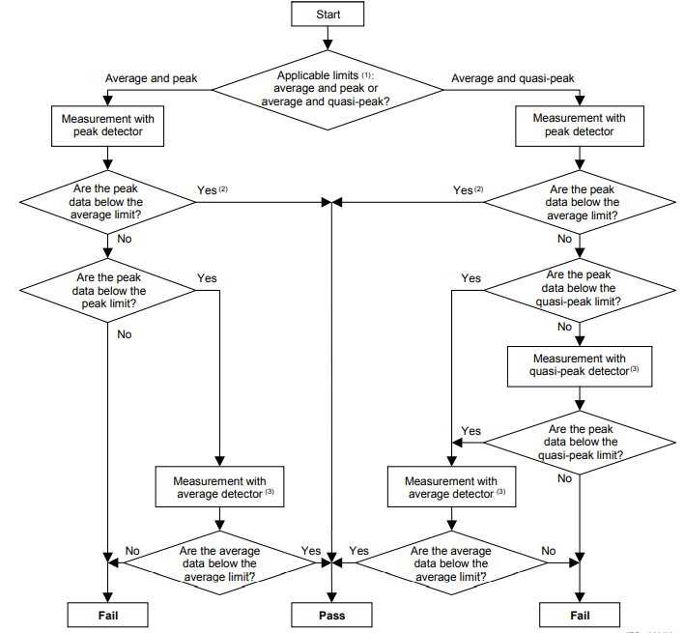

1. **Rod Antenna Setup**

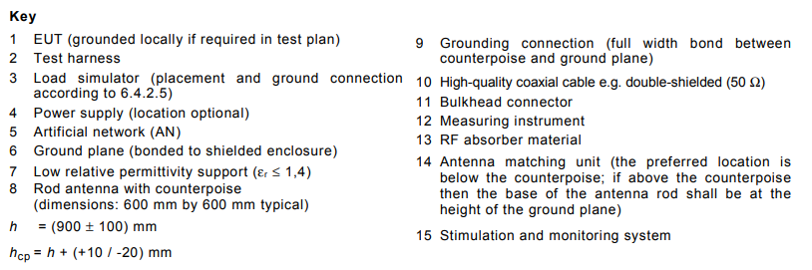

1. **Biconical Antenna Setup**

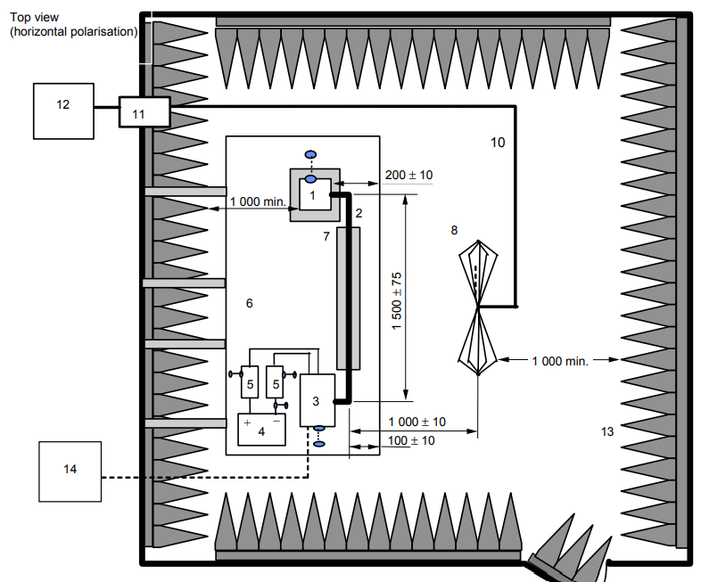

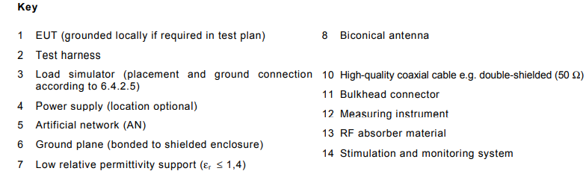

1. **Log-periodic Antenna Setup**

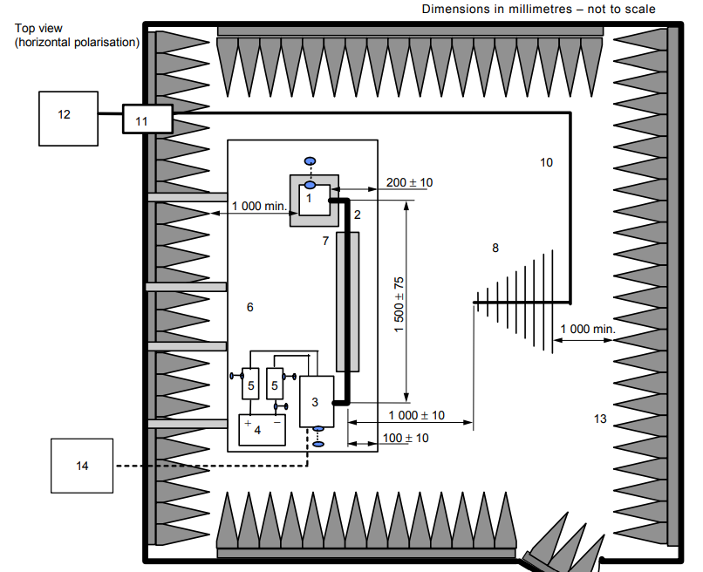

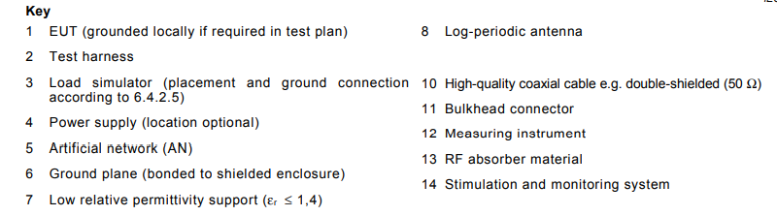

1. **Horn Antenna Setup**

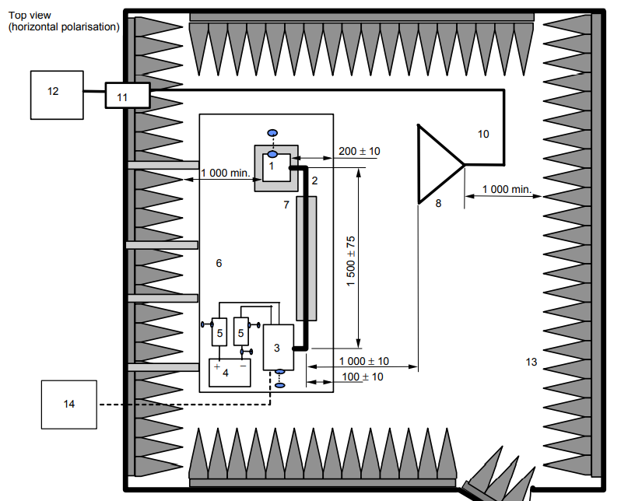

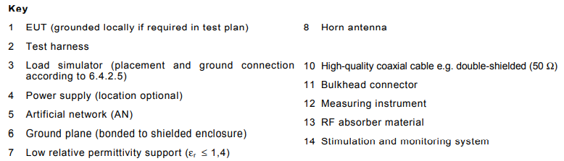

**Radiation Emission Limits:**

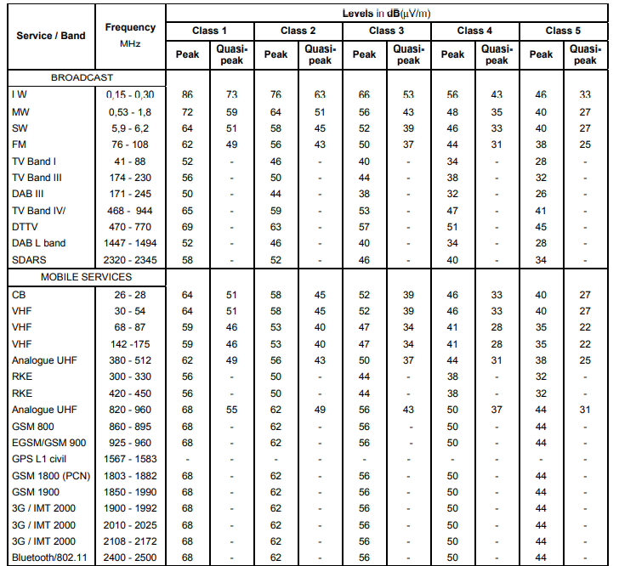

## Conducted Emissions - Voltage on Power leads

Test Specification reference: CISPR-25 Section 6.3

Acceptance Criteria: DUT shall meet CISPR 25 Section 6.3 table 5 Class 4 as a minimum.

## Conducted Emissions - Current probe on cable harness

Test Specification reference: CISPR-25 Section 6.4

Acceptance Criteria: DUT shall meet CISPR 25 Section 6.4 table 6 Class 4 as a minimum

## Interference immunity - BCI on cables

Test Specification reference: ISO 11452-4

Acceptance Criteria: DUT shall be tested up to level 4, meet Test level 2 with FPSC status 1 as a minimum.

## Interference Immunity - ALSE (Antenna)

Test Specification reference: ISO 11452-2

Acceptance Criteria: DUT shall be tested up to level 4, meet Test level 2 with FPSC status 1 as a minimum.

**Purpose:**

The device under test (DUT), together with the wiring harness (prototype or standard test harness), is subjected to an electromagnetic disturbance generated inside an absorber-lined shielded enclosure, with peripheral devices either inside or outside the enclosure. It is applicable only to disturbances from continuous narrowband electromagnetic fields.

It will verify whether DUT will be able to sustain in such an electromagnetic disturbance.

Radiation will be generated by immunity antenna.

**Reference Documents:**

ISO 11452-2

**Test Subjects:**

**Test Range:**

The applicable frequency range of the absorber-lined shielded enclosure test method is 80 MHz to 18 GHz.

**Test apparatus and instrumentation:**

Radiated electromagnetic fields are generated using antenna with a radio frequency (RF) energy source capable of producing the desired field strengths. A set of antennae and multiple RF amplifiers could be required to cover the range of test frequencies.

Measuring equipment:

* Field-generating device: any available antenna (including high-power baluns, if appropriate) capable of radiating the specified field strength at the DUT with the available power may be used.
* Field probes, which should be electrically small and isotropic.
* Artificial network(s)
* HF generator
* High-power amplifier
* Powermeter

**Test set-up:**

**Ground plane:** The ground plane shall be made of 0,5 mm thick copper. The minimum width of the ground plane shall be 1 000 mm.

The minimum length of the ground plane shall be 2 000 mm, or the length of the entire underneath of the equipment plus 200 mm, whichever is the larger.

The height of the ground plane (test bench) shall be (900 ± 100) mm above the floor. The ground plane shall be bonded to the shielded enclosure such that the d.c. resistance shall not exceed 2,5 mΩ. In addition, the bond straps shall be placed at a distance no greater than 0,3 m apart edge to edge.

**Power supply and AN:** Each DUT power supply lead shall be connected to the power supply through an AN.

The AN(s) shall be mounted directly on the ground plane. The case or cases of the AN(s) shall be bonded to the ground plane.

The power supply return shall be connected to the ground plane — between the power supply and the AN(s).

**Location of DUT:** The DUT shall be placed on a non-conductive, low relative permittivity (dielectric-constant) material (εr u 1,4), at (50 ± 5) mm above the ground plane.

**Location of test harness:** The part of the test harness parallel to the front edge of the ground plane shall be (1500 ± 75) mm.

The total length of the test harness between the DUT and the load simulator (or the RF boundary) shall not exceed 2 000 mm. The wiring type is defined by the actual system application and requirement.

**Location of load simulator:** the load simulator shall be placed directly on the ground plane. If the load simulator has a metallic case, this case shall be bonded to the ground plane.

**Location of field generating device (antenna):** The height of the phase center of the antenna shall be (100 ± 10) mm above the ground plane. No part of any antenna radiating element shall be closer than 250 mm to the floor.

The distance between the wiring harness and the antenna shall be (1 000 ± 10) mm.

This distance is measured from.

* the phase center (mid-point) of the biconical antenna,
* the nearest part of the log-periodic antenna,
* the nearest part of the horn antenna.

The phase center of the antenna for frequencies from 80 MHz to 1 000 MHz shall be in line with the center of the longitudinal part (1 500 mm length) of the wiring harness. The phase center of the antenna for frequencies above 1 000 MHz shall be in line with the DUT.

**Biconical Antenna:**

**LOG-Periodic Antenna:**

**Horn Antenna:**

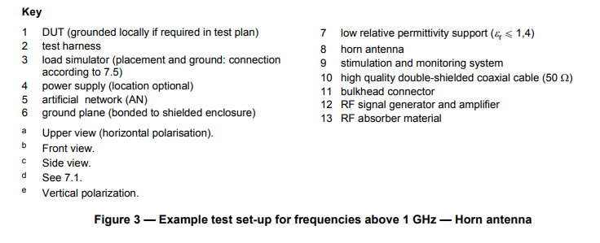

**Test procedure:**

The test shall be performed with the substitution method, which is based upon the use of forward power as the reference parameter used for field calibration and test.

This method is carried out in two phases:

1. field calibration (without the DUT, wiring harness and peripheral devices present)
2. test of the DUT with wiring harness and peripheral devices connected.

**Field calibration:**

Place the electrical phase center of the field probe (150 ± 10) mm above the ground plane and at a distance of (100 ± 10) mm from the front edge of the ground plane.

* For frequencies of from 80 MHz to 1 000 MHz, the phase center of the field probe shall be in line with the center of the longitudinal part (1 500 mm length) of the wiring harness position.
* For frequencies above 1 000 MHz, the phase center of the field probe shall be in line with the DUT position.

Place the field-generating device (antenna) at a distance of (1 000 ± 10) mm from the electrical phase center of the field probe. Calibrate the field strength for vertical and horizontal polarizations.

When requested, the values of forward and reverse power recorded in the calibration file and a precise description of the associated position of the field probe shall be included in the test report.

**DUT test:**

Install the DUT, harness and associated equipment on the test.

Subject the DUT to the test signal based on the calibrated value as predetermined in the test plan.

A field probe may be placed above the wiring harness during the test.

Perform the test for both horizontal and vertical polarization in the appropriate frequency ranges.

**Function performance status classification (FPSC):**

## Interference Immunity – Magnetic Fields

Test Specification reference: ISO 11452-8

Acceptance Criteria: DUT shall be tested up to level 4, meet minimum requirement of Status I at level 2. FPSC as described in ISO 11452-1: Status I-The function performs as designed during and after the test.

## Conducted Transient on power lines.

Test Specification reference: ISO 7637 - 2 Section 4.3

Acceptance Criteria: DUT shall meet level IV of table B.2 as well as ECE #10 and Hyundai section 7.3.7

**Purpose:**

This test is e for evaluating the automotive electrical and electronic components of the device under test (DUT), considered a potential source of conducted disturbances, for conducted emissions of transients along the battery-fed or switched supply lines.

**References Documents:**

ISO 7637 – 2

**Test Subjects:**

**Test Frequency:**

1. Slow pulses (millisecond range or slower)
2. Fast pulses (nanosecond-to-microsecond range)

**Test Facility Setup:**

Voltage transients from the disturbance source, the DUT, are measured using the artificial network to standardize the impedance loading on the DUT. The disturbance source is connected via the artificial network to the shunt resistor, Rs, the switch, and the power supply.

All wiring connections between artificial network, switch, and the DUT shall be spaced 50 mm above the metal ground plane.

The cable sizes shall be chosen in accordance with the real situation in the vehicle, i.e., the wiring shall be capable of handling the operating current of the DUT, and as agreed between vehicle manufacturer and supplier.

If no requirements are specified in the test plan, then the DUT shall be placed on a non-conductive material 50 mm above the ground plane.

The disturbance voltage shall be measured as close to the DUT terminals as possible, using a voltage probe and an oscilloscope or waveform acquisition equipment.

Repetitive transients shall be measured with the switch S closed. If the transient is caused by a supply disconnection, measurement shall be started at the moment of opening switch S.

See the below figures to get clean picture of setup.

**Test Procedure:**

DUT operating conditions of particular interest in the measurements are the turn on, the turn off, and the exercising of the various operating modes of the DUT. The exact operating conditions of the DUT shall be specified in the test plan.

The sampling rate and trigger level shall be selected to capture a waveform displaying the complete duration of the transient, with sufficient resolution to display the highest positive and negative portions of the transient.

Utilizing the proper sampling rate and trigger level, the voltage amplitude shall be recorded by actuating the DUT according to the test plan.

Other transient parameters, such as rise time, fall time and transient duration, may also be recorded. Unless otherwise specified, ten waveform acquisitions are required.

Only those waveforms with the highest positive and negative amplitude (with their associated parameters) shall be recorded. The measured transient shall be evaluated.

All pertinent information and test results shall be reported. If required per the test plan, include transient evaluation results with respect to the performance objective as specified in the test plan.

**Essential elements of transient emissions waveform characteristics:**

**Transient waveform classification table:**

## Conducted Immunity to Transient on power lines

Test Specification reference: ISO 7637 - 2 Section 4.4

Acceptance Criteria: DUT AV shall be tested up to level 4for pulse 1, 2a, 2b, 3a and 3b, meet minimum requirement of Status I at level 2. The function performs as designed during and after the test.

## Coupled Transient Interference on cable harness

Test Specification reference: ISO 7637 - 3

Acceptance Criteria: DUT shall be tested up to level 4, meet minimum requirement of Status I at level 2. The function performs as designed during and after the test.

## Powered Electrostatic Discharge (ESD)

Test Specification reference: EN 61000- 4-2/ISO 10605 section 8

Up to +/-8KV contact or +/-15KV air discharge to accessible parts during operation. Debug ports are included.

Acceptance Criteria: DUT shall meet Status I: The function performs as designed, during and after the test.

## Handling Electrostatic Discharge (ESD)

Test Specification reference:  ISO 10605 Section 9

Handling ESD while the unit is unpowered.   
Direct ESD: +/- 8KV contact or +/- 15KV air discharge.

Acceptance Criteria: DUT shall pass complete function testing successfully after testing has been performed. There shall be no permanent damage.

# References

## Industry Standards

|  |  |
| --- | --- |
| Standards | Description |
| **CISPR-25:2016** | Emission Control |
| **ISO 11452** **–** **4:2011** | Interference Immunity – BCI |
| **ISO 11452** **–** **2:2019** | Interference Immunity – Antenna |
| **ISO 11452** **–** **9:2012** | Interference Immunity – Portable Transmitters |
| **ISO 11452** **–** **8:2015** | Interference Immunity – Magnetic Fields |
| **ISO 7637** **–** **2:2011** | Conducted Immunity |
| **ISO 7637** **–** **3:2016** | Coupled Interference |
| **DIN EN 61000-4-2:2008/ISO 10605:2008** | ESD |
|  |  |

## Motional Requirements

## Acronyms and Terms

|  |  |
| --- | --- |
| Acronym or Term | Definition |
| **ALSE** | Absorber Lined Shielded Enclosure |
| **AMoD** | Automated Mobility on Demand |
| **AV** | Autonomous Vehicle |
| **BCI** | Bulk Current Injection |
| **EMC** | Electromagnetic compatibility. |
| **DUT** | Device under Test |
| **DSRC** | Dedicated short-range communications |
| **ESD** | Electrostatic Discharge |
|  |  |
| **FPSC** | Functional Performance Status Classification |
| **GNSS** | Global Navigation Satellite System |
| **GLONASS** | Global Navigation Satellite System |
|  |  |
|  |  |
|  |  |
|  |  |
|  |  |
|  |  |
|  |  |
|  |  |
|  |  |
|  |  |
|  |  |
|  |  |
| **SOW** | Scope of Work or Statement of Work |